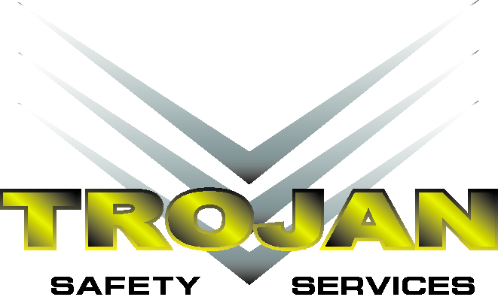

Sales Representative

**Trojan Safety Services AB Ltd in Weyburn Saskatchewan is seeking a Sales Representative to sell and service customers in a manner which exceeds their expectations. The Sales Representative will develop and maintain relationships with customers.**

**Qualifications**

* **3-5 years Oilfield Service Industry Experience**
* **Ability to engage with clients in a product specific discussion**
* **Capable of managing busy account base**
* **Able to build and maintain a broad level of relationships in the industry and the ability to convert these relationships into opportunity**
* **Positive attitude and good organizational skills**
* **Ability to sell services and value**
* **Broad understanding of our services and products**
* **Able to represent Trojan Safety in public settings**
* **Highly mobile and willing to travel where needed to accomplish sales goals**
* **Capable of working an irregular work schedule based on the demands of our customers**
* **Excellent driving record**
* **Excellent verbal and written communication skills**

**Duties and Responsibilities:**

* **Contribute to the organization to build sales consistent with company strategy**
* **Provide feedback to operations managers which ensures quality work**
* **Maintain a regional understanding of Oil & Gas industry**
* **Assist in forecasting responsibilities to sales management**
* **Improves customer service and satisfaction**
* **Attain and increase sales goals through increased market share**
* **Completing paperwork and reporting in a timely matter**
* **Contributing to weekly sales/operations conference calls**
* **Various other duties as required**

**Our Safety Sales Representatives enjoy:**

* **Competitive Pay**
* **Medical, Dental and Vision Insurance Package**
* **Disability and Life Insurance Package**
* **Career Advancement Opportunities**